To install ambari in cloudera vm, 3 steps need to be followed,

* 1. ***sudo yum install epel release***
  2. ***sudo yum install ambari-server***
  3. ***ambari-server setup -j /usr/java/default***

1. Tried the following command as per Hadoop in 24 hrs SAMs

***sudo yum install epel release***

got the following error message

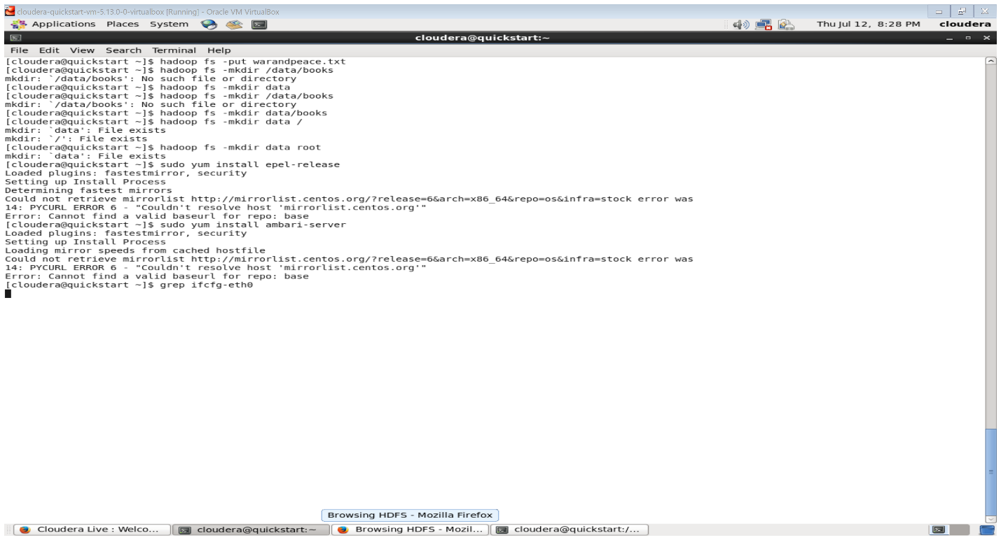

The main error was “PYCURL ERROR 6 – “Couldn’t resolve host ‘mirrorlist.centos.org’

Googling on this error, directed me to this page

<http://www.rohitmenon.com/index.php/how-to-fix-pycurl-error-6-couldnt-resolve-host-mirrorlist-centos-org-2/>

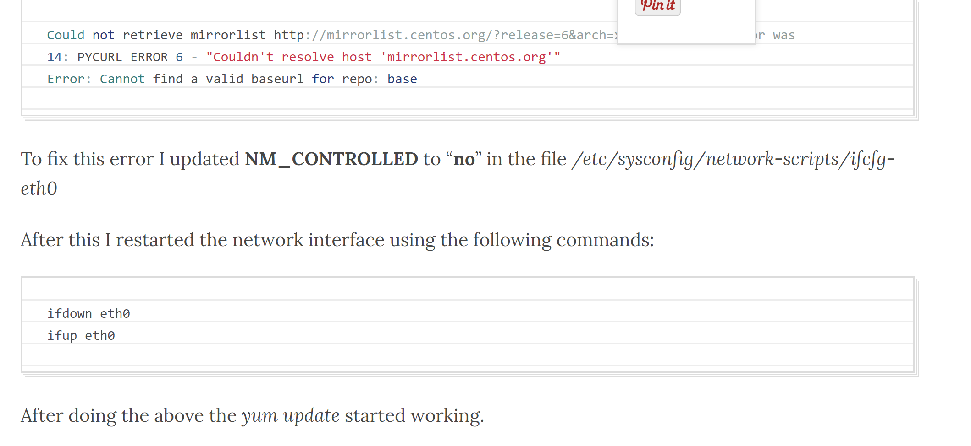

Hence I started following the steps.

1. We need to find the ifcfg-eth0 file in the path /etc/.sysconfig/network-scripts/. Listing the contents of this directory showed that ifcfg-eth0 had only read access for users. The access bit was 644.

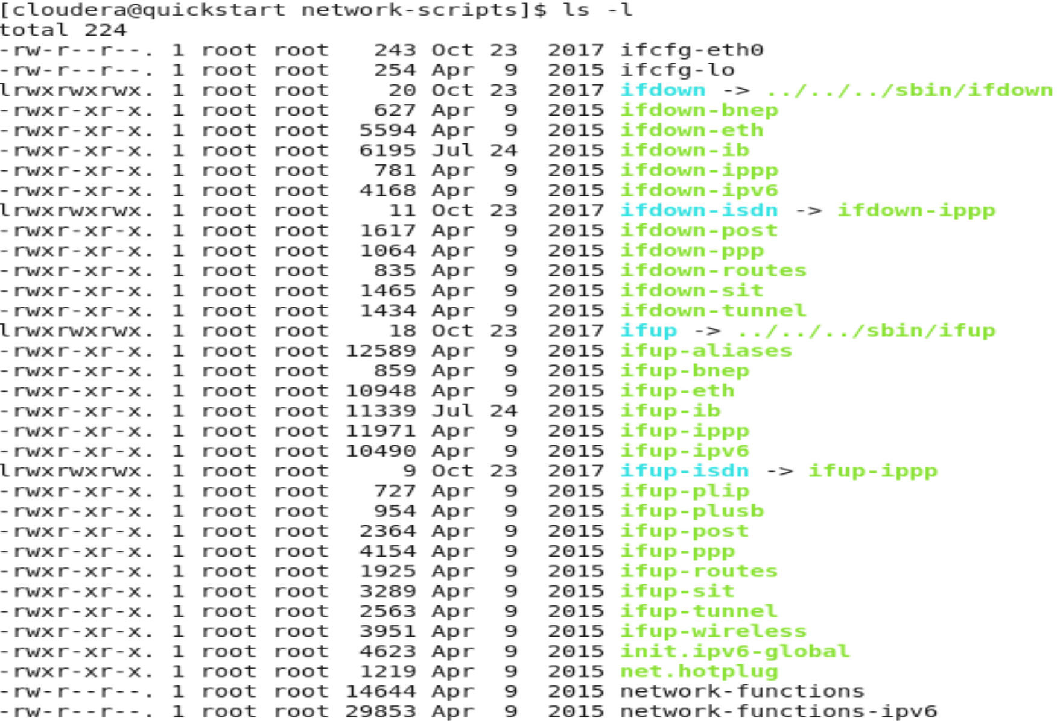

Hence we first need to change the file permission of ifcfg-eth0 to 777 inorder to edit

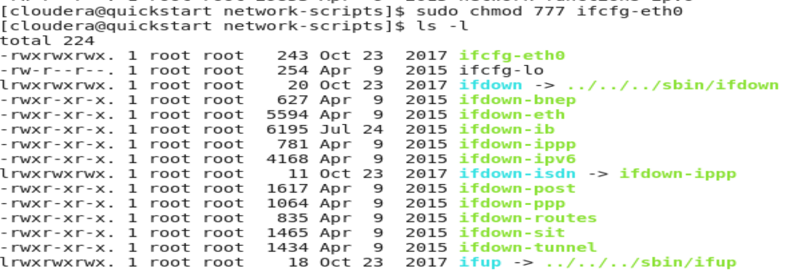

1. Then we need to edit the file using the vi editor and change the value for NM_CONTROLLED to no (By default you will find it having yes)

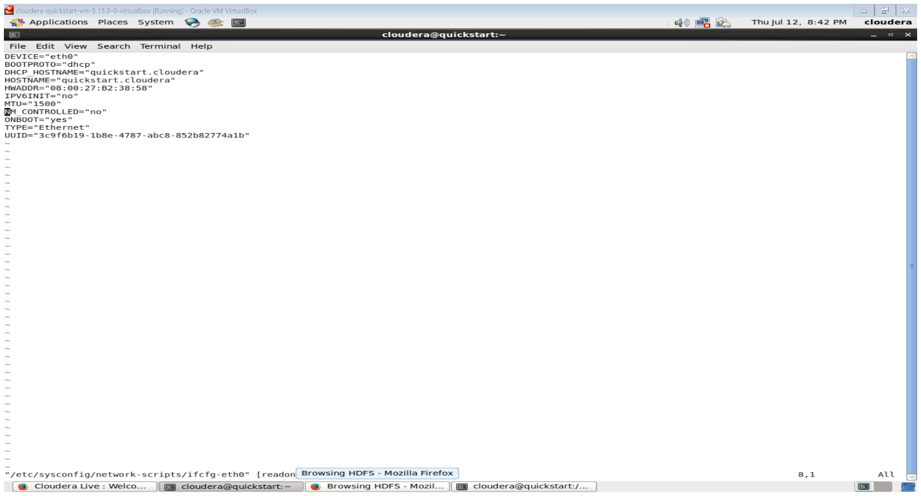

1. Restore the permission of this file back to 644



Now try following the 3 steps to install Ambari

Step1 : ***sudo yum install epel release***

Epel-release successfully installed

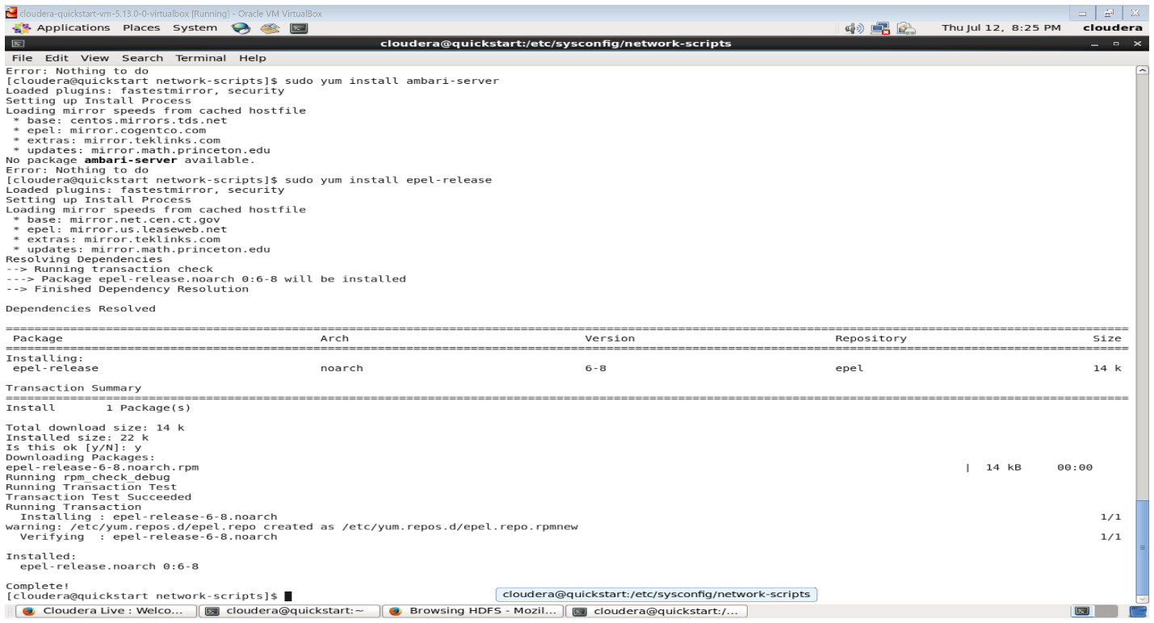

Step2 : ***sudo yum install ambari-server***

Getting error “No package Ambari-Server available”

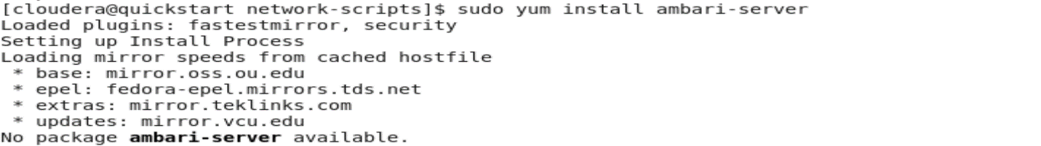

Step3 : sudo yum repolist

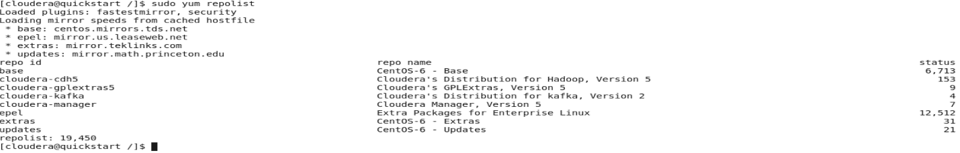

Step 4: Download Ambari

Sudo wget -nv [http://public-repo-1.hortonworks.com/ambari/centos6/2.x/updates/2.6.2.0/ambari.repo -o /etc/yum.repos.d/ambari.repo](http://public-repo-1.hortonworks.com/ambari/centos6/2.x/updates/2.6.2.0/ambari.repo%20-o%20/etc/yum.repos.d/ambari.repo)

Refer the bk-ambari installation guide – page 22.

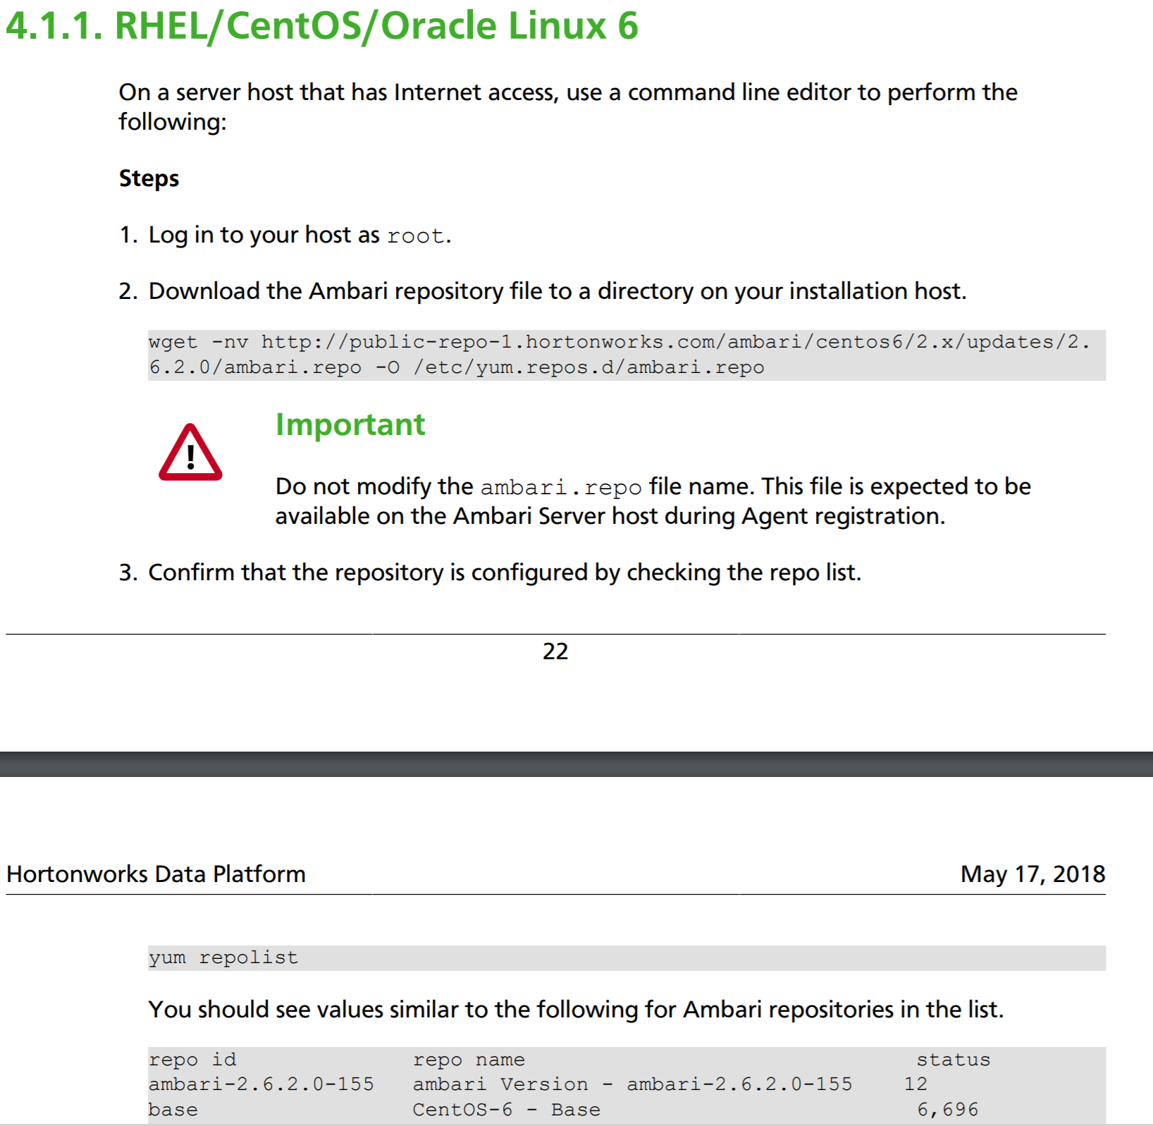

Doing the above step in VM , gives



Now do a check on the softwares downloaded by using repolist

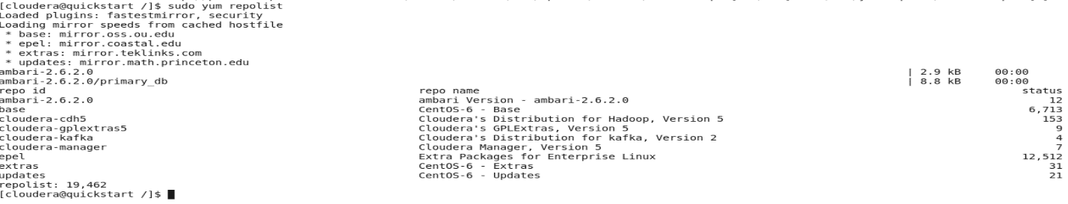

Now install Ambari,

